Equivalent Fractions and Decimals –
Questions

Key Stage 2: 2003 Paper B
1.
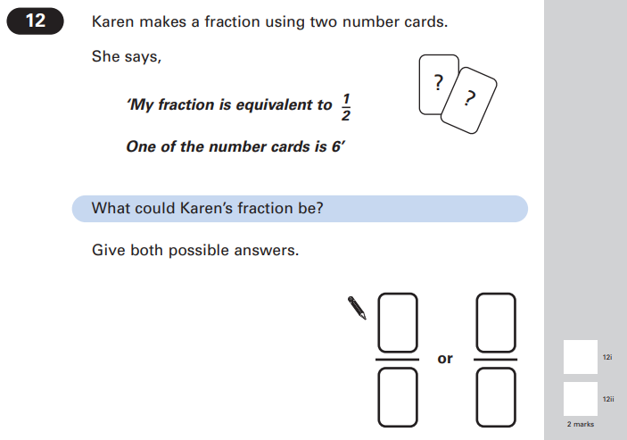

Key Stage 2: 2006 Paper A
1.
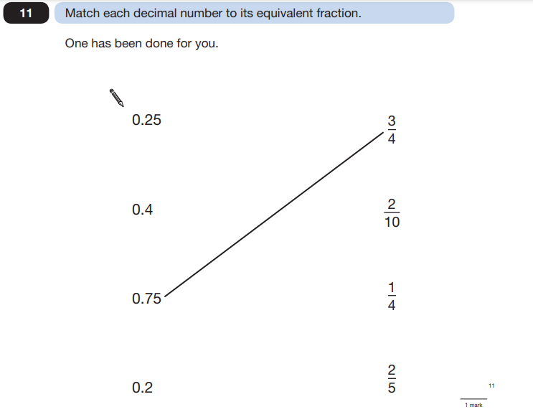
Key Stage 2: 2009 Paper A
1.
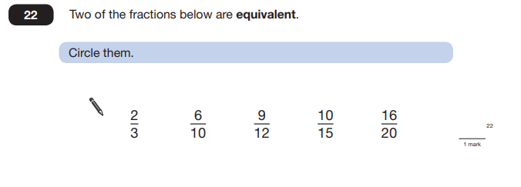
Key Stage 2: 2012 Paper A
1.
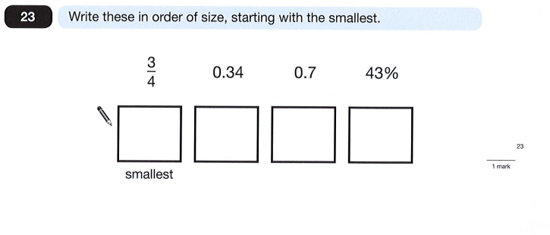

Key Stage 2: 2014 Paper B
1.
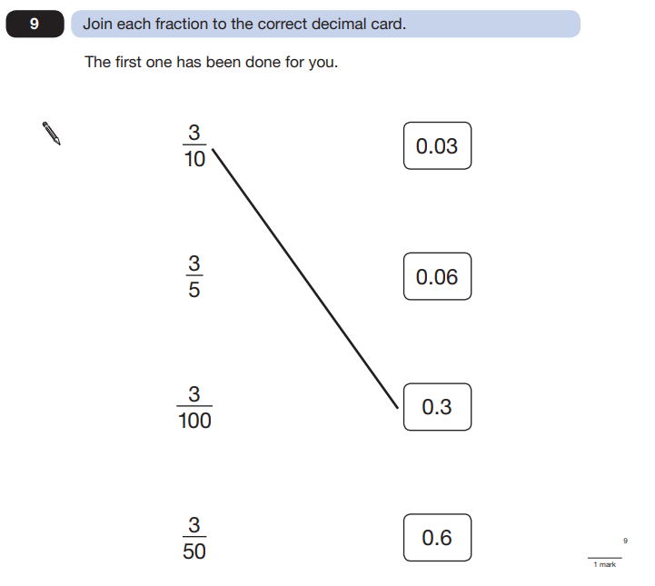

Key Stage 2: 2017 Paper 2 Reasoning
1.
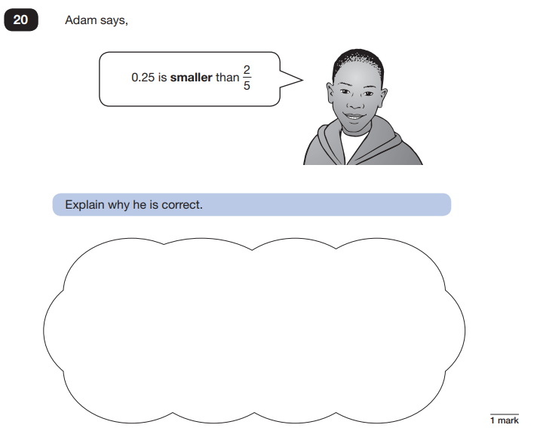

Key Stage 2: 2017 Paper 3 Reasoning
1.
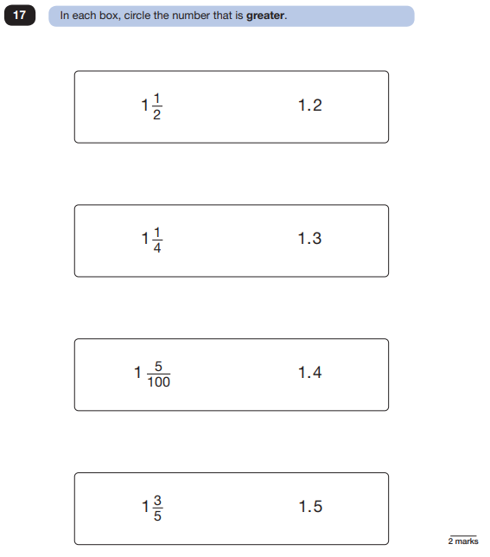

Key Stage 2: 2018 Paper 2 Reasoning
1.
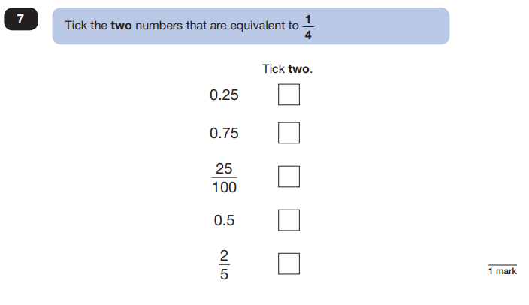
Key Stage 2: 2019 Paper 2 Reasoning
1.
